**Lecture #18**

**PROPERTIES OF THE POISSON PROCESS**

We are studying Poisson processes with constant rate l, which are known as *homogeneous* Poisson processes.

1. Mean, variance, autocorrelation

We already know that:

Exp[ X(t) ] = Var[ X(t) ] = lt.

It can also be shown that, for t2 > t1:

rxx( X(t1), X(t2) ) = sqrt( t1/t2 )

Significance? Think about when t2 = t1 and t2 >> t1.

2. Poisson process can be viewed as a Markov process.

That is, for t3 > t2 > t1:

Prob[ X(t3) = n3 | X(t2) = n2 , X(t1) = n1 ] = Prob[ X(t3) = n3 | X(t2) = n2 ]

The proof of this property follows from the defining equation.



Significance?

Common sense interpretation?

3. The sum of two independent Poisson processes is a Poisson process.

The proof is simple and interesting.

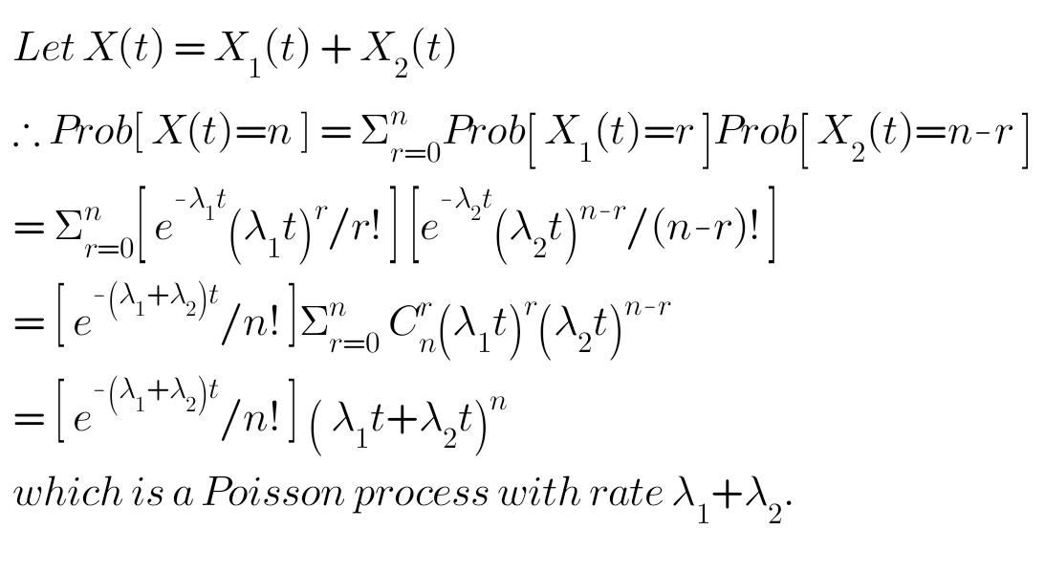

4. The difference of two Poisson processes is NOT a Poisson process.

One proof is given in the book.

But there is yet another simple way to reason.

Let X(t) = X1(t) - X2(t)

In a given time interval Dt, it can certainly happen that the second process occurs more number of times than the first. In such cases, the value of X(t) will be calculated as < 0, which can never result from a Poisson process!

5. Mean “inter-arrival” time, T

Here “inter-arrival" time is the time interval between two successive occurrences of the even which is described by the Poisson process.

Let Ek and Ek+1 be two consecutive occurrences of the event, and let T be the time interval between them. Note that T is a continuous RV.

Without loss of generality, say that Ek occurs at time 0. Since X(t) is a Poisson process, we know that:



Prob[ T > t ] = Prob[ X(t) = 0 ] = e–lt

Recall that the cdf of RV T is defined by Prob[ T < t ]. Let F(t) represent the cdf of T.

Therefore F(t) = Prob[ T < t ] = 1 – Prob[ T > t ] = 1 – e–lt

Now recall that, for a continuous RV, the probability density is obtained as the derivative of the cdf.

Therefore the probability density of the “inter-arrival" time T is given by f(t) = le–lt, which is an exponential distribution with mean = 1/l. Verify this! Note also that the unit of “inter-arrival” time must be – and is – the reciprocal of the unit of “rate".

Simple example (from reference)

Customer arrivals at a counter define a Poisson process with mean rate of 2 arrivals per minute. Find the probability that the interval between two consecutive arrivals is:

(a) more than 1 minute,

(b) between 1 and 2 minutes, and

(c) 4 minutes or less.

Answer in all cases is the integral of f(t) = e–lt between lower limit L and upper limit U, which are to be suitably determined in all three cases.